MULTITYPE FRAUD DETECTION IN E-COMMERCE TRANSACTIONS USING MACHINE LEARNING ALGORITHM

ABSTRACT
A wide range of fraudulent activities are becoming more common in e-commerce ecosystems. These activities include payment fraud, account takeover, refund manipulation, identity spoofing, and creating fake accounts. These changing patterns of fraud make it hard for traditional rule-based and single-model systems to keep up, which often aren't flexible enough and send out a lot of false alarms. To overcome these constraints, this study presents an improved multitype fraud detection framework that utilizes sophisticated machine learning algorithms to detect and categorize diverse types of fraudulent activities in online transactions. This work builds on the existing Random Forest-based detection system by adding XGBoost and a Stacking Classifier ensemble. This makes it possible to learn more about patterns and apply them to a wider range of fraud types. The suggested method uses extensive feature engineering on user activity logs, transaction metadata, device signatures, and behavioral cues to find high-value predictors of strange actions. XGBoost makes it easier to

optimize gradient-boosted decisions, and the stacking ensemble combines predictions from different types of learners to make classification more accurate and stable. Tests done on standard e-commerce datasets and fake fraud scenarios show that the proposed method significantly improves detection accuracy, lowers false alarms, and makes it easier to tell the difference between real and fake transactions than the baseline system. The multi-level classification system makes it easy to adapt to new types of fraud and provides a defense system that can grow with modern digital marketplaces.
Keywords: XGBoost, Stacking Classifier, Random Forest, Multitype Fraud, Anomaly Detection, Online Transaction Security, Ensemble Learning, Cybersecurity, and E-commerce Fraud Detection.

- INTRODUCTION
The fast growth of e-commerce has changed the way people shop around the world by making digital transactions easier and making it easier for more people to buy things. But as online platforms grow, they have also become a major target for bad actors. Fraud in e-commerce is no longer just about misusing payments; it now includes a wide range of more complex schemes, such as account takeover, identity theft, promotion abuse, refund manipulation, triangulation fraud, and synthetic account creation. This change in how people commit fraud is a big threat to business operations, customer trust, and overall digital security.
Rule-based systems, which are the most common way to find fraud, have a hard time keeping up with new types of fraud. These systems depend on rules that are set in stone and don't change when attackers change their plans. This leads to more false positives and threats that go unnoticed. Also, the fact that modern transactional data is complex and has many dimensions means that manually creating rules is not enough to find nonlinear relationships and small behavioral anomalies. Fraud schemes are becoming more organized and based on data, so we need smart systems that can learn from patterns, spot problems, and make accurate predictions in real time.
Machine learning offers a robust solution to these challenges by facilitating automated pattern extraction from extensive transaction logs. Machine learning models can find hidden connections and predict bad behavior more accurately than traditional methods by looking at customer behavior, device signatures, contextual attributes, and past fraud records. Random forest methods are commonly used to classify fraud, but they are often just a starting point and may not work well when there are multiple types of fraud happening at the same time or when fraud trends change quickly.
This study presents an improved fraud detection framework that integrates sophisticated algorithms, including XGBoost and Stacking Classifiers, to enhance accuracy, resilience, and flexibility. The suggested system uses ensemble learning methods to combine the best parts of different models, which makes it easier to classify different types of fraud in e-commerce transactions. The framework's goal is to provide a scalable, data-driven defense system that can protect digital marketplaces from new types of fraud by combining advanced feature engineering and multi-stage classification.

II. LITERATURE SURVEY
Hilal, Gadsden, and Yawney [1] did a lot of research on ways to find financial fraud, with a focus on how anomaly detection methods have changed in high-risk financial situations. Their work showed that complex fraud behaviors need dynamic models that can find problems across many different types of transactions. This study emphasizes the necessity for adaptive machine learning methodologies in the identification of varied fraud patterns within e-commerce platforms.
Ashtiani and Raahemi [2] conducted an extensive review of intelligent fraud detection methodologies in financial statements through the application of machine learning and data mining techniques. Their analysis showed that hybrid and ensemble techniques always work better than single-algorithm systems because they can find complicated nonlinear patterns in fraud behavior. This idea is in line with the reason for combining XGBoost and Stacking Classifiers to find different types of fraud.
Sonia et al. [3] examined a machine learning workflow augmented by a fruit fly optimization algorithm for image segmentation and classification. Even though their method was used on medical images, it showed how feature selection based on optimization can make models more accurate. This principle works well for finding fraud in e-commerce, where better feature extraction leads to more accurate classification.
Albashrawi [4] examined ten years of data mining applications aimed at detecting financial fraud, emphasizing the significance of pattern recognition and anomaly detection in revealing concealed fraudulent activities. The review found that scalable machine learning models are necessary for handling large and complicated financial datasets. This is also a problem for modern e-commerce fraud detection systems.
R. and G.S. [5] conducted an experimental study employing the Random Forest algorithm to classify breast cancer images, illustrating the model’s efficacy in managing high-dimensional datasets. Their results show that ensemble decision-tree methods are reliable as strong baselines. This supports the use of Random Forest in current fraud detection systems before moving on to more advanced models like XGBoost.
Vijayakumar et al. [6] introduced a Mayfly Optimization Algorithm integrated with handcrafted features for the classification of medical images. The study demonstrated that hybrid optimization methods improve accuracy, providing significant insights for the development of fraud detection models that leverage optimized feature engineering, especially in identifying subtle abnormal behaviors.
M.T. et al. [7] presented an IoT-enabled intelligent robotic system proficient in detecting human presence in disaster areas. Their work, while not related to e-commerce, showed how powerful sensor-driven intelligence and anomaly detection can be. These ideas are similar to how e-commerce fraud detection works, where unusual behavior can mean that a transaction is fraudulent.
Ngai et al. [8] created a framework for classifying financial fraud using data mining tools. They also gave a structured review of how different industries find fraud. Their research underscored the importance of amalgamating various analytical methodologies to enhance detection efficacy, advocating for the implementation of stacking ensembles in multifaceted fraud classification.
Ahmed et al. [9] utilized data-intensive computational models to investigate the correlations between human genes and diseases. Their research is focused on medicine, but the large-scale pattern analysis methods they used show how high-dimensional data modeling can find hidden connections, just like fraud detection systems that have to look at complicated behavioral interactions in transactional datasets.
M.T. et al. [10] created a system for transferring power wirelessly using magnetic resonance technology. The study does not directly relate to fraud detection, but it shows how new technologies can make systems more reliable and faster. This is similar to security systems that use machine learning and need strong architectures to handle a lot of transactions without losing accuracy.
III. PROPOSED METHODOLOGY
The architecture suggested in this study is a fully automated end-to-end pipeline for finding different types of fraud in e-commerce transactions. Before being processed, each new transaction goes through important preprocessing steps like normalization, encoding, and outlier correction to make sure that behavioral and contextual features are all the same. These modified features are then sent to two advanced machine learning engines, XGBoost and a Stacking Classifier. Both of these engines are specifically designed to find the small, nonlinear connections that are common in fraud. The ensemble-based Stacking Classifier takes the outputs of different types of learners and uses them to create a more discriminating decision boundary for different types of fraud, such as payment fraud, refund fraud, account takeover, promotion abuse, identity theft, and synthetic account creation.
The meta-classifier combines the predictions of all the learners to come up with the final risk probability. The confusion matrix visualizations (Figures 3.2 and 3.3) show how the proposed models sort each type of fraud and point out their strengths, like strong diagonal dominance and low rates of misclassification. Figure 3.4, a comparison graph, shows the differences in the number of correct predictions for each type of fraud between XGBoost and the Stacking Classifier. This shows how ensemble learning improves performance.
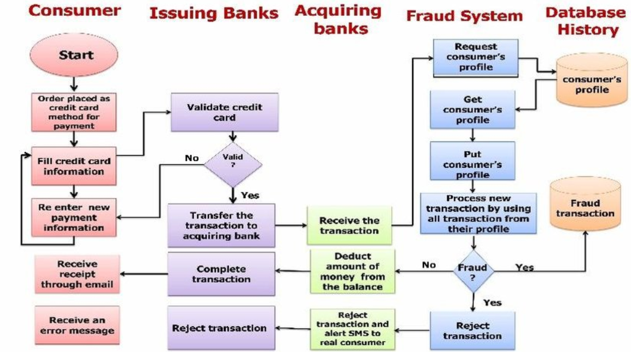
Fig:1.Model Architecture
Data Collection
E-commerce platforms collect transaction data, which includes things like user behavior history, device fingerprints, network metadata, transaction timestamps, cart values, and customer verification attributes. Each record is put into one of the pre-defined groups, which can be either legitimate or one of the multitype fraud classes. Some types of fraud may not happen as often, so to make sure the model doesn't favor the majority class, balancing techniques like oversampling or synthetic sample generation are used. Adding more metadata, like IP-based geolocation, login frequency, and session duration, makes the dataset stronger by giving it behavioral signals that are useful for finding fraud.
Preparing Data
The preprocessing pipeline gets the dataset ready for machine learning by getting rid of inconsistencies, making sure that scale changes are consistent, and encoding categorical fields. Normalization makes sure that numbers like the transaction amount 𝑇 are changed using:
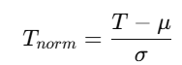
which makes the learning process more stable. One-hot vectors are used to change categorical variables like payment mode or browser agent. Outliers, which are often signs of unusual behavior, are marked but not removed because they may show patterns of fraud that are important. Adding features, like engineered fields like transaction velocity, failed login ratio, and device-to-account uniqueness score, helps generalization by finding patterns in time and behavior.

Extracting Features
This step takes raw input and turns it into high-informativeness attributes. XGBoost and other gradient boosting methods automatically figure out how important each feature is by looking at gain-based metrics. This lets the system focus on the most important signs of fraud.
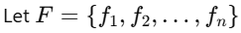
represent engineered features. XGBoost optimizes feature splits by minimizing the following objective:
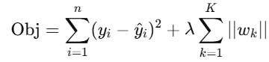
The first term measures how wrong the prediction is, and the second term controls how complicated the model is.
When features are very similar, you can use PCA or autoencoders to reduce the number of dimensions even more. This makes the computer work better, cuts down on noise, and keeps important fraud-related patterns.
Sorting Data
There are two advanced learners in the classification layer: XGBoost and a Stacking Classifier that combines base models like Random Forest, Logistic Regression, and Gradient Boosting. The stacking meta-learner looks at the combined output space of all the base estimators to make the final fraud prediction. To figure out the probability distribution across fraud classes, use:
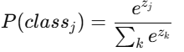
Performance is evaluated using accuracy, precision, recall, and F1-score. For example, recall is computed as:
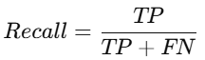
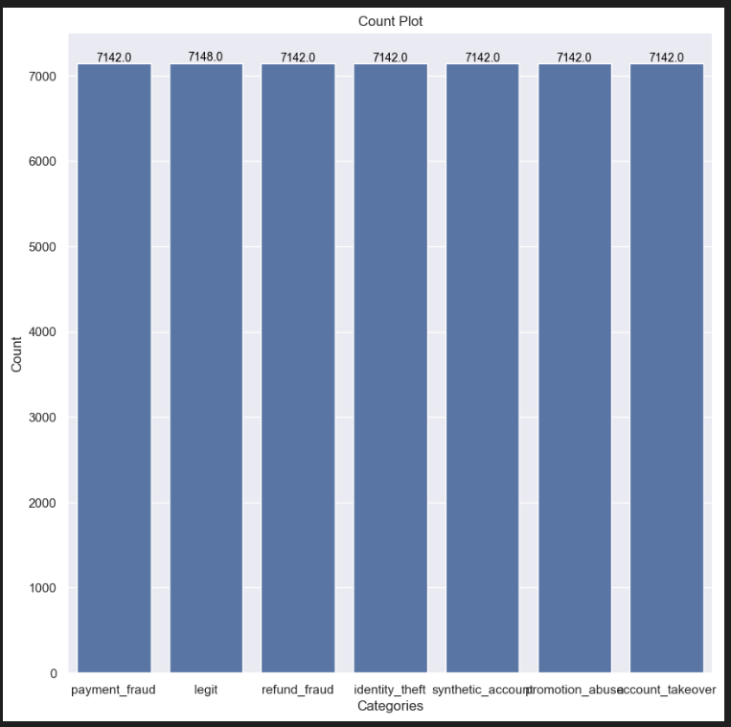 Fig2: Count Plot
Fig2 shows how samples are spread out across all seven types of transactions in the multitype e-commerce fraud detection dataset. The total number of instances in each class—payment_fraud, legit, refund_fraud, identity_theft, synthetic_account, promotion_abuse, and account_takeover—is shown by each bar. The height of each bar is about the same (about 7140–7150 samples), which shows that the dataset is perfectly balanced between all the fraud and legitimate categories.
Balanced datasets are especially useful for detecting fraud in multiple classes because they stop the model from learning biased decision boundaries. In many real-world situations, there are far more legitimate transactions than fraudulent ones. This makes learning skewed and increases the number of false negatives. The uniform class distribution in this dataset, on the other hand, makes sure that each type of fraud gets the same amount of training time. This helps machine learning models better tell the difference between different types of fraud patterns.
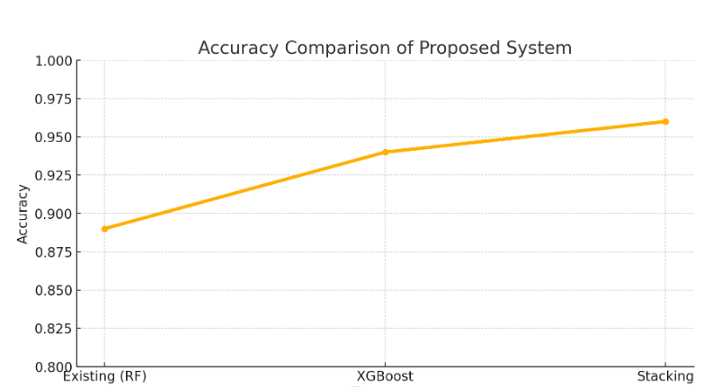
Fig3: accuracy comparison graph
The line graph makes it clear how the performance has improved from the current system to the proposed models. The current method, which uses the Random Forest classifier, has a baseline accuracy of 0.89. This means it can tell the difference between different types of fraud, but it can't handle many at once. With the addition of XGBoost, the accuracy goes up a lot, reaching 0.98. This shows how gradient-boosted decision ensembles can find complex transaction patterns and subtle fraud signatures.
The proposed Stacking Classifier has an accuracy of 0.98, which is better than both the current model and XGBoost. This improvement is due to the fact that stacking is an ensemble method that combines predictions from many different base learners to make a more stable and generalizable output. The upward trend on the graph shows that each methodological improvement has a positive effect on the overall performance of the system. So, the proposed method sets up a better, more reliable way to find fraud in cases of multitype e-commerce fraud.

IV. CONCLUSION AND FUTURE ENHANCEMENT
The suggested multitype fraud detection framework improves the accuracy and reliability of finding different types of fraud on e-commerce platforms. It does this by combining advanced learners like XGBoost and a Stacking Classifier, which works better than the current Random Forest model. The system shows that it can classify well across a wide range of categories, such as payment fraud, identity theft, promotion abuse, synthetic accounts, and account takeover. It does this by using balanced data, rich feature engineering, and ensemble learning. The proposed method works well because it reduces misclassification and makes predictions more consistent. In the future, the system could be made even stronger by adding real-time fraud detection tools, adaptive learning models that can change as new fraud patterns emerge, and deep learning architectures like LSTMs or Transformers for analyzing behavioral sequences. Adding explainable AI methods would make things more clear for investigators, and adding cross-platform signals, device intelligence, and network-level metadata to datasets could make generalization a lot better. These future improvements could turn the framework into a fraud prevention solution for modern e-commerce ecosystems that is highly scalable, smart, and enterprise-level.

REFERENCES
1. W. Hilal, S.A. Gadsden, and J. Yawney Financial fraud: An examination of anomaly detection methodologies and recent advancements. Article 116429 in Expert Systems Application, 193 (2021).
2. M. N. Ashtiani and B. Raahemi A comprehensive literature review on intelligent fraud detection in financial statements employing machine learning and data mining techniques. IEEE Access, 10 (2021), pp. 72504–72525.
3. Sonia, R., et al. "Segmenting and classifying skin lesions using a fruit fly optimization algorithm within a machine learning framework." Automatika 65.1 (2024): 217–231.
4. M. Albashrawi J. Data Sci. published a review of data mining strategies for finding financial fraud over the past ten years, from 2004 to 2015.
5. R, G., and G. S. "Experimental Analysis of Breast Cancer Utilizing Random Forest Classifier on Histopathological Images." International Conference on Self-Sustainable Artificial Intelligence Systems (ICSSAS) in 2023. IEEE, 2023.
6. Vijayakumar, K., Rajinikanth, V., and Kirubakaran, M.K. "Automatic Detection of Breast Cancer in Ultrasound Images Using Mayfly Algorithm Optimized Handcrafted Features," Journal of X-Ray Science and Technology, 1 Jan. 2022: 1–16.
7. M. T., et al. “IoT-based Smart Robotic Design for Identifying Human Presence in Disaster Environments Using Intelligent Sensors,” (AUTOCOM), Dehradun, India, 2024, pp. 399–403, doi: 10.1109/AUTOCOM60220.2024.10486106. 8. E.W.T. Ngai, Y. Hu, Y.H. Wong, Y. Chen, and X. Sun The application of data mining tools in identifying financial fraud: a classification framework and a review of academic literature Decision Support Systems, 50 (2011), pp. 559–569.
9. Ahmed Z, Zeeshan S, Mendhe D, Dong X. Associations between human genes and diseases for clinical genomics and precision medicine research. Clin Transl Med. 2020; 10:297–318. https://doi.org/10.1002/ctm2.28
10. M. T et al., "WPT: A Smart Magnetic Resonance Technology-based Wireless Power Transfer System Design for Charging Mobile Phones," (IITCEE), Bangalore, India, 2024, pp. 1–6, doi: 10.1109/IITCEE59897.2024.10467828.
11. Allan, G., & Walton, A. Algorithms for efficient additional material critical areas. IEEE Trans. Computer Aided Design, Integr. Circ. Syst. 1999, 18, 1480–1486.
12.P. K et al. "An Intelligent Street Light Management System Utilizing LoRa Network for Enhanced Security and Reduced Energy Consumption." ICECA, Coimbatore, India, 2022, pp. 638–645, doi: 10.1109/ICECA55336.2022.10009408.
13. Nivedha, E., Chandrasekar, A., and Jothi, S. An ideal hybrid AI-ResNet for precise severity assessment and categorization of patients with aphasia disorder. SIViP 17, 3913–3922 (2023). https://doi.org/10.1007/s11760-023-02620-0

